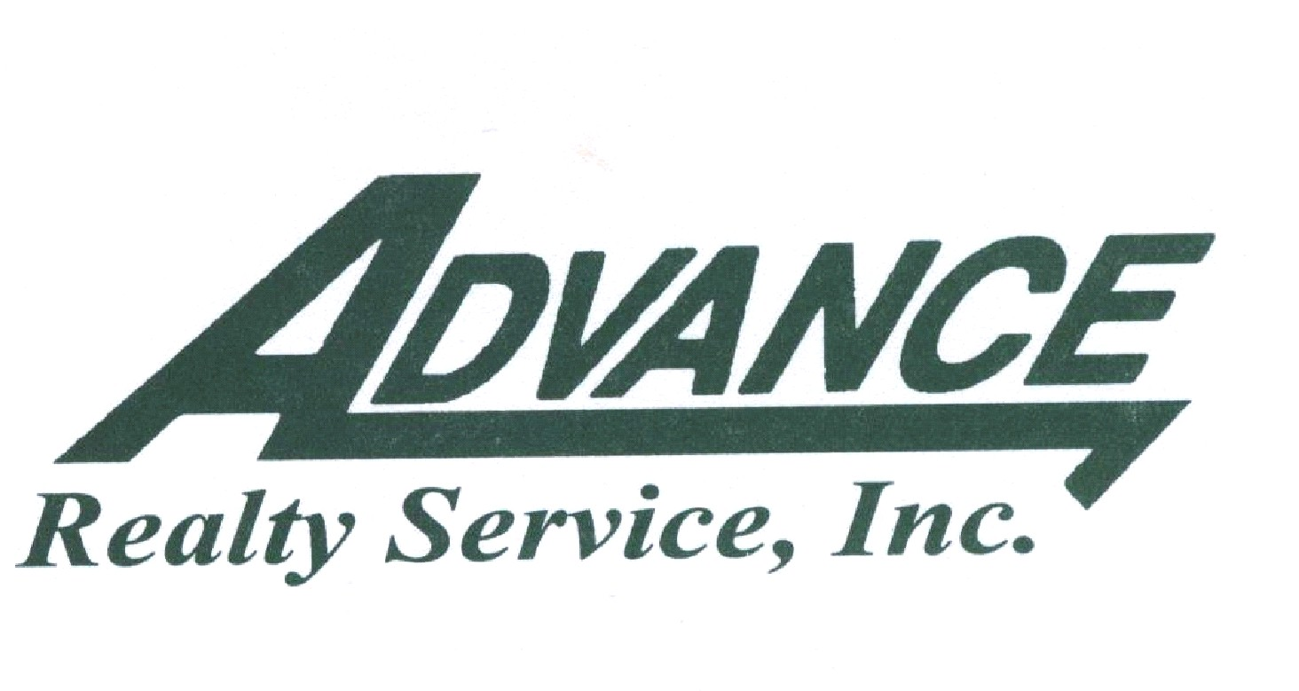

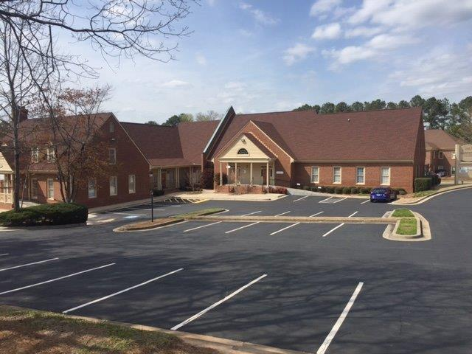

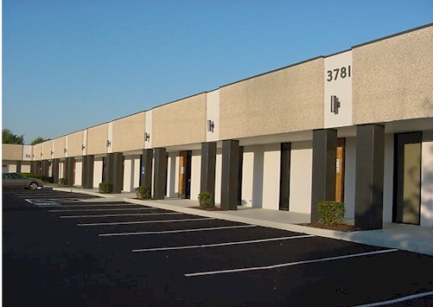
1867 Independence Square
Dunwoody, GA 30338

Sr. VP of Operations & Leasing | Rebecca D. Duncan
Executive Admin Assistant | Anice Charles-Walker
Maintenance Technician: | David Hayes

Leasing and Property Management Office: | 4500 Hugh Howell Rd.  Suite 780  Tucker, GA 30084
Phone: | 770-220-2626
Emergency Maintenance: | David Hayes – (404)-542-0893 C
Office Hours: | Monday-Friday  8:30am-5:30pm

Thank you for choosing Independence Square. Here at Advance Realty Service, Inc. it is our goal to cater to your specific needs. We have compiled a list of places and numbers which might be of value to you. Enjoy your time here and please contact us if there is anything else we can do for you.

Fire Department | For an Emergency - call 911  DeKalb County Fire and Rescue Services  (678)-406-7750
Police Department | For an Emergency – call 911  Dekalb County Police Department  (678)-937-5301  Dunwoody Police Department  (678)-382-6900
U.S. Post Office | 1551 Dunwoody Village Pkwy, Atlanta (2.1 miles)  4707 Ashford Dunwoody Rd, Atlanta (2.2 miles)

Property Management Office | (770)-220-2626
Emergency Maintenance- After Hours | David Hayes – (770)-634-2409 Cell

Comcast Business Services | 1-(800)-391-3000
AT & T: Phone Service  Internet Service | 1-(888)-757-6500  1-(888)-321-2375

- Electricity: Provided by Landlord as part of a full service lease.

- Gas: Provided by the Landlord.

- Water: No expense to the tenants. Water/sewer is paid by the property/Landlord. The only time a tenant would be charged for water/sewer is if a specific tenant is an excessive user for which the Landlord has the right to install a sub-meter and charge that tenant for its usage.

- Telephone/DSL/Internet Access: Paid for by Tenant under Tenant’s own agreement with its choice of service provider. Tenant will need to make prior arrangements for access to the mechanical room. Please call the Management Office at least 24 hours in advance to arrange access to this room.

5. Inside Maintenance: Tenants are responsible for their own inside maintenance
including janitorial service, changing light bulbs and plumbing issues.

Each Tenant is required to have one Primary Sign Unit on their Suite. All sign units, including additional symbols or logos, must be submitted to Landlord for approval prior to fabrication, and installation. The cost of fabrication and installation of each sign unit and permits shall be the responsibility of Tenant. Any installed non-conforming or unapproved sign shall be brought into conformance at the non-conforming tenant’s expense. All signage should be ordered from Fast Signs (Joey Vaughan), 4135 LaVista Road, Tucker, GA 30084 (770) 934-2200, email address: fastsigns.174@fastsigns.com

No advertising placards, banners poster, pennants, flags, names, insignia, trademarks, or other descriptive material shall be affixed or maintained upon either the interior or upon the exterior walls of the building.

Property Manager
Your Property Manager for maintenance and repairs may be reached at 770-220-2626. Please call to report any roof leaks, exterior lights out or any other maintenance issues.

Monthly Rental Payment
Rent is due in our office on or before the first of each month. Please send your payment to the address listed on your rental invoice so that it reaches us on time. Late payments will be charged a 10% late fee in accordance with the terms and conditions of your lease.

The payment address is:
Sunset Harbor (Gainesville) LLC
4500 Hugh Howell Road
Suite 780
Tucker, GA 30084

Keys/Building Access
Each Tenant shall receive two (2) keys to the suite at move in time. Additional keys may be ordered at any time. A charge of $3.00 will be added to your rental invoice for any additional keys.

Please have your insurance carrier send us a current certificate of insurance listing the following:

- The Landlord (Certificate Holder) should be listed as Sunset Harbor (Gainesville) LLC.

- Landlord should also be listed as “An Additional Insured” with respects to the Premises.

- The Premises should be listed on the certificate as 1867 Independence Square, Suite _____ (insert your suite number in the blank), Dunwoody, GA 30338.

- The Tenant shall carry public liability insurance to protect both Tenant and Landlord as stipulated in your lease agreement.

- The certificate of insurance shall provide that the policy may not be canceled before the expiration date of the Lease without giving at least thirty (30) days written notice to the Landlord (Certificate Holder).

The following rules apply to moving furniture, equipment and supplies in and out of the building.

MOVERS THAT DO NOT ADHERE TO THE FOLLOWING RULES WILL NOT BE ALLOWED TO ENTER THE PREMISES AND WILL BE REQUIRED TO DISCONTINUE THE MOVE.

- Landlord must be notified of the move at least 24 hours in advance.

- Management must be notified in advance of any after-hours, weekend or holiday moves.

- Move-ins of large quantities of furniture, equipment, or supplies must be accomplished after 5:30 p.m. on weekdays, or on weekends or holidays.

- Movers must provide protective covering on all vulnerable corners, walls, door facings and other areas along the route to be followed during the move.

- Never stick duct tape onto floors, walls, door jambs or doors.

- Due to the limited size of the trash dumpster, the Tenant is responsible for the removal of all packing boxes and material when the move-in or delivery involves several items.

- There is to be no smoking inside the building(s) by any employee of the moving company.

- All moving company employees should be in uniform or wear an identification card at all times.

- The moving company must carry insurance. A certificate of insurance must be presented to Landlord at least two (2) business days prior to the move. All moving company employees must be bonded.

Parking is available for all Tenants and their guest. Parking is available on a first come basis. Unauthorized or improperly parked vehicles will be towed and/or ticketed at vehicle owner’s expense. Abandoned vehicles will be towed at the expense of the vehicle owner.

One person in your office should coordinate all maintenance and repair requests, and that person should call the Property Manager at 770-220-2626.

Solicitation is not permitted on the property.

The DeKalb County Clean Air Ordinance prohibits smoking in all public places in DeKalb County.

The Landlord is responsible for maintaining the landscaping at the property. In order to keep the property well maintained, we ask that you do not disturb the landscaping. Please avoid walking on the grass or planted areas in a manner that causes a worn area to appear.

We encourage each tenant to take all necessary security precautions. Prior to the installation of any security monitoring equipment, please contact the Landlord. The installation of any security monitoring equipment for your suite must first receive the Landlord’s prior written approval. Please watch out for your neighbor, and together we can make the property safer.

1. No painting shall be done, nor shall any alterations be made, to any part of the building by putting up or changing any partitions, doors or windows, nor shall there be any nailing, boring or screwing into the woodwork or drywall, nor shall any connection be made to the electric wires or gas or electric fixtures without the written consent on each occasion by Landlord. All glass, locks and trimming in or upon the doors and windows of the Property shall be kept whole and, when any part thereof shall be broken, even if through no fault of tenant, the same shall be immediately replaced or repaired and put in order at tenant expense, under the direction and to the satisfaction of Landlord, and shall be left whole and in good repair. Tenant shall not make any penetrations of the roof, and any such penetrations made by the tenant shall entitle the Landlord to treble damages for removal and repair of the roof damage so caused. If the tenant paints or engages in other actions as described above, with or without the consent of the Landlord, the Tenant agrees that upon the termination of the Lease, the Landlord shall repaint or otherwise restore the Property by engaging contractors of Landlord’s choice and the cost of such painting and/or restoration shall be an additional amount due from the Tenant to the Landlord.

2. There shall be no sign, lettering, picture, notice, or advertisement installed on or in any part of the Premises and visible from the exterior of the building, or visible from the exterior of the Premises, without Landlord’s approval in writing. In the event of a violation of the foregoing by Tenant, Landlord may remove the same without any liability and may charge the expense incurred by such removal to Tenant. Landlord shall have the right to prohibit any advertising by Tenant which in Landlord's reasonable opinion tends to impair the reputation of the building or its desirability as a building for its intended and lawful use, and upon written notice from Landlord, Tenant shall refrain from or discontinue such advertising

3. It tenants desire blinds over the windows, they must be of such shape, color and materials as prescribed by Landlord, and shall be erected with Landlord’s written consent and at the expense of the desiring tenants. No awnings shall be placed on the Property. If tenants require wiring for a bell or buzz system, such wiring shall be done by the electrician of the Landlord only and no outside wiring technician shall be allowed to do work of this kind unless with the written permission of Landlord. If telegraphic or telephonic service is desired by Tenant; no boring or cutting for wiring shall be done unless first approved by Landlord in writing. The electric current shall not be used for Tenant heating unless written permission to do so has been obtained from Landlord, and at an agreed cost to tenant.

4. Tenant, employees, customers, invitees, and guests shall not obstruct sidewalks, entrances, passages, corridors, vestibules, halls, or stairways in and about the building which are used in common with other tenants and their employees, customers, guests, and invitees, and which are not a part of the Premises of Tenant. Tenant shall not place objects against glass partitions or doors or windows which would be unsightly from the Building corridors or from the exterior of the Building and will promptly remove any such objects upon written notice from Landlord. The water closets and other water apparatus shall not be used for any other purpose than those for which they were construction and no sweepings, rubbish, paper towels or other obstructing substances shall be thrown therein. Tenant shall be responsible for the inside maintenance of the premises including plumbing, pest control, electrical, changing light bulbs and janitorial service and supplies.

5. In no event shall Tenant bring into the building firearms, inflammables, such as gasoline, kerosene, naphtha and benzene, or explosives, or any other article of intrinsically dangerous nature. Tenant shall not operate electrical heaters within the premises. Tenant shall comply with all applicable federal, state, and municipal laws, ordinances, and regulations, and building rules and shall not directly or indirectly make any use of the Premises which may be prohibited by any of the foregoing or which may be dangerous to persons or property or obstruct or interfere with the rights of other tenants or in any way injure or annoy them, or conflict with the laws relating to fires, or with the regulations of the Fire Department, or any part thereof, or conflict with any of the rules and ordinances of the Board of Health or may increase the cost of insurance or require additional insurance coverage.

6. Tenants, their employees and agents, shall maintain order in the Property, shall not make or permit any improper noise vibrations or use or operate any electrical or mechanical devices that emit excessive sound, or create obnoxious odors, any of which may be offensive to the other tenants and occupants of the Building, or that would interfere with the operation of any device, equipment, radio, television broadcasting or reception from or within the Building or elsewhere and shall not place or install any projections, satellite dishes, antennas, aerials, or similar devices inside or outside of the Premises or on the Building. No rooms shall be occupied or used as sleeping or lodging apartments at any time. No part of the Property shall be used or in any way appropriate for gambling, immoral or other unlawful practices, and no intoxicating liquor or liquors shall be sold or consumed in said Property. Tenants shall not injure, overload, or deface the Property, the woodwork or the walls of the premises nor carry upon the premises any noisome, noxious, noisy or offensive business. Tenant shall have the right to operate microwave ovens and coffee makers exclusively for the benefit of its employees and invitees. There is no cooking in the premises including outside grills without proper permits from the city and/or county governments having jurisdiction over the property and without Landlord’s written permission. No dogs, animals, birds, bicycles, or other vehicles shall be allowed within the premises or the halls, corridors or elsewhere in the Property. If, by reason of the failure of Tenant to comply with the provisions of this subparagraph, any insurance premium for all or any part of the building shall at any time be increased, Tenant shall make immediate payment of the whole of the increased insurance premium, without waiver of any of Landlord's other rights at law or in equity for Tenant's breach of this Lease. Additionally, upon determination of a Tenant having a dog, animal, bird or other pet, with the exception of “Service Animals”, within the premises, the Landlord shall be entitled to charge a fee of $1,000.00 to the Tenant for each instance for this violation.

7. Tenant shall not waste electricity, water, or air conditioning and shall cooperate fully with Landlord to insure the most effective operation of the building’s heating and air conditioning systems and shall refrain from attempting to adjust any controls other than unlocked room thermostats, if any, installed for Tenant's use. Tenant shall keep exterior doors closed.

8. Tenant assumes full responsibility for protecting its space from theft, robbery, and pilferage, which includes keeping doors locked and other means of entry to the Premises closed and secured after normal business hours. All inside lighting should be turned off after normal business hours. Tenant should report to Landlord any outside lighting that is inoperable.

9. Landlord shall furnish two keys for each lock on exterior doors to the premises. Tenant is responsible for buying extra keys and replacement keys at their own expense. No additional locks or similar devices shall be attached to any door or window. In addition, if changing of the locks is required by the Tenant after Tenant's initial occupancy, the Landlord must be notified immediately. The locks will be changed by the Landlord at Tenant’s expense. Upon termination of this Lease or of the Tenant's possession, the Tenant shall surrender all keys of the Premises and shall explain to the Landlord all combination locks on safes, cabinets, and vaults.

10. Any carpeting installation approved by Landlord and cemented down by Tenant shall be installed with a releasable adhesive. In the event of a violation of the foregoing by Tenant, Landlord will charge the expense incurred by such removal to Tenant.

11. No electric circuits for any purpose shall be brought into the leased premises without Landlord's written permission.

12. All loading, unloading, receiving, or delivery of goods, supplies and furniture shall be made only through entryways provided for such purposes indicated by Landlord. Landlord shall specify the hours when loading, unloading, receiving or delivery can take place so as not to interfere with other tenants. Disposal of garbage or refuse shall be made by Tenant only to designated dumpster located on the Property for such purposes. Tenant cannot put wood in the dumpster. Tenant needs to dispose of wood and wood products at their own expense. Tenant shall be responsible for any damage to the building or the property of its employees or others and injuries sustained by any person whomsoever resulting from the use or moving of such articles in or out of the Premises and shall make all repairs and improvements required by Landlord in connection with the use or moving of such articles.

13. All safes, equipment, or other heavy articles shall be carried in or out of the Premises only at such time and in such manner as shall be prescribed in writing by Landlord, and Landlord shall in all cases have the right to specify the proper position of any such safe, equipment, or other heavy article, which shall only be used by Tenant in a manner which will not interfere with or cause damage to the Premises or the Building in which they are located, or to the other tenants or occupants of said Building. Tenant shall be responsible for any damage to the building or the property of its employees or others and injuries sustained by any person whomsoever resulting from the use or moving of such articles in or out of the Premises and shall make all repairs and improvements required by Landlord in connection with the use or moving of such articles.

14. Canvassing, soliciting, and peddling in the building is prohibited and each Tenant shall cooperate to prevent the same.

15. Vending machines shall not be installed without written permission of the Landlord, except for those vending machines used exclusively by Tenant's employees within the Tenant’s leased space.

16. Wherever in these Building Rules and Regulations the word “Tenant” occurs, it is understood and agreed that it shall mean Tenant's associates, agents, clerks, and visitors. Wherever the word “Landlord” occurs, it is understood and agreed that it shall mean Landlord's assigns, agents, clerks, and visitors.

17. Landlord shall have the right to enter the Premises at all reasonable hours for the purpose of inspecting the same.

18. Landlord shall have the right to enter the Premises at hours convenient to the Tenant for the purpose of exhibiting the same to prospective tenants within the 90-calendar day period prior to the expiration of this Lease.

19. At all times the Landlord’s employees or agents shall be in charge of the building and persons entering or departing from the building may be questioned as to their business in the building. Landlord shall in no case be liable for damages for any error or other action taken with regard to the admission to or exclusion from the building of any person.

20. All entrance doors to the Premises shall be locked when the Premises are not in use. All exterior doors shall also be closed during times when the air conditioning equipment in the building is operating so as not to dissipate the effectiveness of the system or place an overload thereon.

21. Landlord reserves the right at any time and from time to time to rescind, alter, or waive, in whole or in part, any of these Rules and Regulations when it is deemed necessary, desirable, or proper, in Landlord's judgment, for its best interest or for the best interest of the tenants of the building.

22. Tenant, its employees, customers, invitees, and guests shall not smoke within the Premises or other areas within the park.

23. Tenant may install a Wireless Fidelity Network (or similar system) (“Wi-Fi Network”) for intranet, internet, or communications purposes within its Premises. Such Wi-Fi Network may not interfere with the use of any other space within the building. Should any interference occur, Tenant shall take all necessary steps as soon as commercially practicable and no later than three calendar days following such occurrence to correct such interference. If such interference continues after such three-day period, Tenant shall immediately cease operating Tenant’s communications equipment until such interference is corrected or remedied to Landlord’s satisfaction. Tenant acknowledges that Landlord has granted and/or may grant leases, licenses and/or other rights to other tenants and occupants of the building and to telecommunication service providers.

24. Tenant shall cooperate with Landlord in any programs in which Landlord may elect to participate relating to the Building’s (i) energy efficiency, management, and conservation; (ii) water conservation and management; (iii) environmental standards and efficiency; (iv) recycling and reduction programs; and/or (v) safety, which participation may include, without limitation, the Leadership in Energy and Environmental Design (LEED) program and related Green Building Rating System promoted by the U.S. Green Building Council.

25. Landlord will not be responsible for lost or stolen personal property, money, or jewelry from any tenant’s leased premises on vehicles.

26. No tenant may enter into phone rooms, electrical rooms, mechanical rooms, or other service areas of the project unless accompanied by Landlord or building management.

27. Tenant will provide to Landlord a list of emergency contact names and telephone numbers that may be used 24/7 for communication or notifications of emergencies.

28. Tenant shall give immediate notice to Landlord in case of theft, unauthorized solicitation, or accident in the premises or in the park or any other known emergency.

29. Tenant may elect to request certain “premises” services such as changing light bulbs, rekeying locks, toilet issues etc. from the Landlord by completing a Tenant service request form. The completed form should include tenant information and the services required and be delivered to property management. Services performed by property management staff shall be invoiced to Tenant at $40 per hour on a minimum $20 per half hour plus material cost.

30. Tenant and Tenant's employees, agents, visitors, and licensees shall observe faithfully and comply strictly with the foregoing rules and regulations including all parking rules and such other and further appropriate rules and regulations as Landlord or Landlord's agent may from time to time adopt. Notice of any additional reasonable and

nondiscriminatory rules and regulations shall be given in such manner as Landlord may reasonably elect.

Suite | Tenant | Service
100 | Georgia Chiropractic Group LLC | Doctors Office
102 | Skalski CPA’s | CPA Office
103 | Asset Strategists LLC | Lawyer/CPA Office
104 | Dr. Scott Veal | Dentist Office
105 | Vianka Garza | Aesthetician/Massage
201 | Vacant | Lawyers Office

Restaurant | Address | Number | Distance Away (miles)
J Alexanders | 4701 Ashford Dunwoody Rd | (770) 512-0153 | 2.10
Chick-fil-A | 2480 Jett Ferry Rd | (770) 391-9277 | 2.90
McDonald’s | 1842 Cotillion Dr | (770) 730-0741 | 0.80
Olive Garden | 4749 Ashford Dunwoody Rd | (678) 441-0270 | 3.20
Goldbergs Fine Foods | 4520 Chamblee Dunwoody Rd | (770) 455-1119 | 0.60
Burger King | 4567 Chamblee Dunwoody Rd | (770) 206-1337 | 0.60
Cheesecake Factory | 4400 Ashford Dunwoody Rd | (678) 320-0201 | 2.07
Lucky China | 4524 Chamblee Dunwoody Rd | (770) 458-5199 | 0.7
Singha 99 Thai | 5554 Chamblee Dunwoody Rd | (770) 390-8619 | 1.72
Gilly’s Sport Bar | 4343 Dunwoody Park | (770) 817-2789 | 0.70
Jimmy Johns | 5479 Chamblee Dunwoody Rd Suite B | (678) 395-3021 | 1.90
El Azteca Mexican Restaurant  Moe’s Southwest Grill | 1412 Dunwoody Village Pkwy  5562 Chamblee Dunwoody Rd | (770) 399-7757  (678) 320-0360 | 2.02  2.20
Wendy’s | 1170 Perimeter Center West | (770) 391-9886 | 3.30
Subway | 4511 Chamblee Dunwoody Rd | (770) 394-3439 | 0.80

Place | Address | Number | Distance (miles)
Perimeter Mall | 4400 Ashford Dunwoody Rd | 770-394-4270 | 2.07
Buford Highway Farmers Market | 5600 Buford Hwy NE | 770-455-0770 | 4.10
Kroger | 4498 Chamblee Dunwoody Rd | (770) 451-8350 | 0.70
Publix | 5550 Chamblee Dunwoody Rd | (678) 443-0644 | 0.60
Georgetown Park | 4400 Dunwoody Park Dr | 770-564-3060 | 0.50
Marcus Jewish Recreation Center | 5342 Tilly Mill Rd | 678-812-4000 | 2.40
LA Fitness | 1155 Mount Vernon Hwy | (770) 350-4951 | 3.20
Dunwoody Zaban Park | 5342 Tilly Mill Rd | (770) 396-3250 | 2.40

